Architecture Design

Analysing Swiggy: Bangalore delivery outlet data Ankita Chetan Chaudhari

[AUTHOR NAME]

[AUTHOR NAME]

## Contents

1. Introduction .............................................................................................................................................. 4
   1. What is Architecture design document? ............................................................................................ 4
   2. Scope ................................................................................................................................................... 4
2. Architecture of Power BI ........................................................................................................................... 5
   * 1. Data Sources ......................................................................................................................................... 5
     2. Power BI Desktop .................................................................................................................................. 6
     3. Power BI Service .................................................................................................................................... 6
     4. Power BI Report Server ......................................................................................................................... 6
     5. Power BI Gateway ................................................................................................................................. 6
     6. Power BI Mobile .................................................................................................................................... 6
     7. Power BI Embedded .............................................................................................................................. 6
3. Working of Power BI Architecture ............................................................................................................ 7

...................................................................................................................................................................... 7

* 1. On-Premise ......................................................................................................................................... 8
  2. On-Cloud ............................................................................................................................................. 8

1. Power BI Service ........................................................................................................................................ 9
   1. Front End cluster ................................................................................................................................. 9
   2. Back End Cluster .................................................................................................................................. 9
   3. Working of Power BI Service ............................................................................................................... 9

## 1. Introduction

1.1 What is Architecture design document?

Any software needs the architectural design to represents the design of software. IEEE defines architectural design as “the process of defining a collection of hardware and software components and their interfaces to establish the framework for the development of a computer system.” The software that is built for computer-based systems can exhibit one of these many architectures. Each style will describe a system category that consists of:

* A set of components (e.g.: a database, computational modules) that will perform a function required by the system.
* The set of connectors will help in coordination, communication, and cooperation between the components.
* Conditions that how components can be integrated to form the system.
* Semantic models that help the designer to understand the overall properties of the system.

### 1.2 Scope

Architecture Design Document (ADD) is an architecture design process that follows a step-by-step refinement process. The process can be used for designing data structures, required software architecture, source code and ultimately, performance algorithms. Overall, the design principles may be defined during requirement analysis and then refined during architectural design work [AU

## 2. Architecture of Power BI

Power BI is a business suite that includes several technologies that work together. To deliver outstanding business intelligence solutions, Microsoft Power BI technology consists of a group of components such as:

* Power Query (for data mash-up and transformation)
* Power BI Desktop (a companion development tool)
* Power BI Mobile (for Android, iOS, Windows phones)
* Power Pivot (for in-memory tabular data modeling)
* Power View (for viewing data visualizations)
* Power Map (for visualizing 3D geo-spatial data)
* Power Q&A (for natural language Q&A)

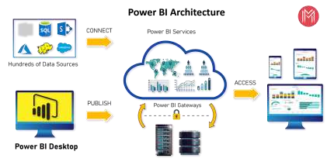

### 1. Data Sources

An important component of Power BI is its vast range of data sources. You can import data from files in your system, cloud-based online data sources or connect directly to live connections. If you import from data on-premise or online services there is a limit of 1 GB. Some commonly used data sources in Power BI are:

* Excel
* Text/CSV
* XML
* JSON
* Oracle Database
* IBM DB2 Database
* MySQL Database
* PostgreSQL Database
* Sybase Database
* Teradata Database
* SAP HANA Database
* SAP Business Warehouse server
* Amazon Redshift
* Impala
* Google BigQuery (Beta)
* Azure SQL Database
* Salesforce Reports
* Google Analytics
* Facebook
* GitHub

### 2. Power BI Desktop

*Power BI Desktop is a client-side tool known as a companion development and authoring tool. This desktop-based software is loaded with tools and functionalities to* connect to data sources, transform data, data modeling and creating reports.

You can download and install Power BI Desktop in your system for free. Using Power BI Desktop features, one can do data cleansing, create business metrics and data models, define the relationship between data, define hierarchies, create visuals and publish reports.

### 3. Power BI Service

Power BI Service is a web-based platform from where you can *share reports made on Power BI Desktop, collaborate with other users, and create dashboards.*

It is available in three versions:

* Free version
* Pro version
* Premium version

Power BI Service is also known as, **“Power BI.com”**, **“Power BI Workspace”,** **“Power BI Site”** and **“Power BI Web Portal”**. This component also offers advanced features like *natural language Q&A* and *alerts*.

### 4. Power BI Report Server

The Power BI Report Server is similar to the Power BI Service. The only difference between these two is that Power BI Report Server is an on-premise platform. It is used by organizations who do not want to publish their reports on the cloud and are concerned about the security of their data.

Power BI Report Server enables you to create dashboards and share your reports with other users following proper security protocols. To use this service, you need to have a Power BI Premium license.

### 5. Power BI Gateway

This component is used to connect and access on-premise data in secured networks. Power BI Gateways are generally used in organizations where data is kept in security and watch. Gateways help to extract out such data through secure channels to Power BI platforms for analysis and reporting.

### 6. Power BI Mobile

Power BI Mobile is a native Power BI application that runs on iOS, Android, and Windows mobile devices. For viewing reports and dashboards, these applications are used.

7. Power BI Embedded

Power BI Embedded offers APIs which are used to embed visuals into custom applications.[AUTHOR

## 3. Working of Power BI Architecture

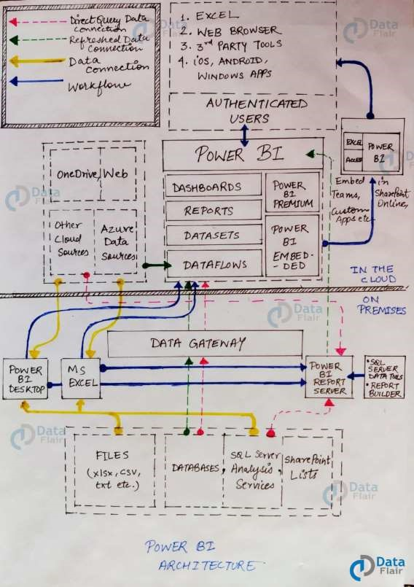

### 3.1 On-Premise

Power BI Desktop is a companion development, authoring, and publishing tool. You can import data from data sources to Power BI Desktop and use it to create reports and then publish them on a Power BI Service or Power BI Report Server.

You can also publish Excel workbooks directly using Power BI Publisher for Excel to the Power BI Report Server. The SQL Server Data tools and Report Publisher help in *creating datasets, KPIs, mobile reports, paginated reports,* etc. The reports from all kinds of reports are published to the Power BI Report Server from where they are distributed to the end-users.

### 3.2 On-Cloud

An important component in Power BI architecture is the Power BI Gateway. The Power BI Gateway acts as a secure channel to transport data from on-premise data sources to on-cloud apps or sites.

On the cloud side of the architecture, resides a lot of components. Like a complete Power BI suite having *dataflows, datasets, dashboards, reports, Power BI Embedded, Power BI Premium,* etc. You can embed your reports and dashboards into *Teams, SharePoint, custom applications,* etc. There are on-cloud data sources as well that connects to Power BI tools via direct connections.

At last, there is a layer of authenticated users who share the published reports and dashboard and collaborate with one another to make educated decisions based on the insights. There are different kinds of users who consume Power BI reports and dashboards and connect through *web browsers, Excel, third-party tools, and mobile devices* (iOS, Windows, Android apps).

## 4. Power BI Service

Users can access the reports and dashboards from Power BI Service using client platforms like websites, mobile devices, etc. This means that every client who wants to access content created on Power BI needs to interact with Power BI Service. And so, we must take a look under the hood and learn how Power BI Service works.

Power BI Service’s architecture consists of two parts:

A front end

A back end

### 4.1 Front End cluster

The front end also called the web front-end cluster acts as an intermediary between clients and the back end. The front end services are used for establishing an initial connection and authenticating clients using Azure Active Directory. The Azure Active Directory stores user identities.

Along with this, Azure Traffic Manager is used to direct user requests to the nearest data center after authentication. Once a client/user is authenticated, the **Azure Content Delivery Network (CDN)** distributes static Power BI content/files to users.

### 4.2 Back End Cluster

The front end also called the web front-end cluster acts as an intermediary between clients and the back end. The front end services are used for establishing an initial connection and authenticating clients using Azure Active Directory. The Azure Active Directory stores user identities.

Along with this, Azure Traffic Manager is used to direct user requests to the nearest data center after authentication. Once a client/user is authenticated, the Azure Content Delivery Network (CDN) distributes static Power BI content/files to users.

### 4.3 Working of Power BI Service

* Power BI stores its data in two main repositories; **Azure block storage** and **Azure SQL database**. Azure block storage stores the datasets uploaded by users and all the metadata and system-related data is stored in the Azure SQL database.
* After Azure API Management authenticates a user request, it is sent to the Gateway Role. The Gateway Role processes the requests and directs them to suitable components like *Presentation Role, Background Job Processing Role, Data Role, and Data Movement Role.*
* For instance, the Presentation Role handles all the visualization related queries like for dashboards and reports.
* For all the data related queries, the request is sent by the Gateway Role to the Data Role or Data Movement Role.
* Power BI Service back end uses Azure Service Bus to connect on-premise datasources with the cloud. Azure Service Bus receives all the requests to fetch data from the on-premise data source. Then it processes the request and executes the query on the on-premise data source to retrieve data from it to the cloud service.
* The Azure Service Fabric manages all the microservices and components associated with running Power BI.
* Azure AD Cache helps in real-time reporting using the data stored in the in-memory of the Power BI system

[

**The End**